Chapter 17, Solution 13.

Design a problem to help other students to better understand obtaining the Fourier series from a periodic function.

Although there are many ways to solve this problem, this is an example based on the same kind of problem asked in the third edition.

Problem

A periodic function is defined over its period as

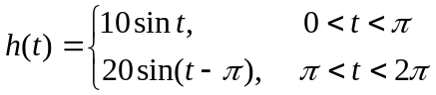

Find the Fourier series of h(t).

Solution

T = 2π, ω_{o} = 1

a_{o} = (1/T)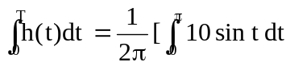+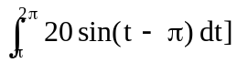

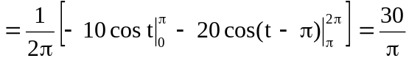

a_{n} = (2/T) 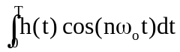
= [2/(2π)] 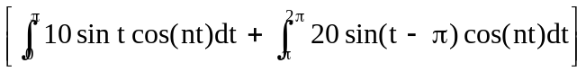

Since sin A cos B = 0.5[sin(A + B) + sin(A – B)]
sin t cos nt = 0.5[sin((n + 1)t) + sin((1 – n))t]
sin(t – π) = sin t cos π – cost sin π = –sin t
sin(t – π)cos(nt) = –sin(t)cos(nt)

a_{n} =

= 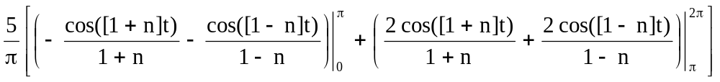

a_{n} = 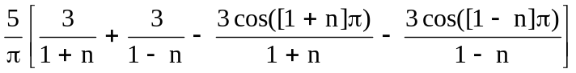

But, [1/(1+n)] + [1/(1-n)] = 2/(1–n²)

cos([n–1]π) = cos([n+1]π) = cos π cos nπ – sin π sin nπ = –cos nπ

a_{n} = (5/π)[(6/(1–n²)) + (6 cos(nπ)/(1–n²))]

= [30/(π(1–n²))](1 + cos nπ) = [–60/(π(n²–1))], n = even
= 0, n = odd

b_{n} = (2/T)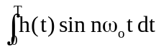

= [2/(2π)][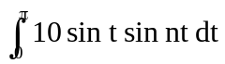+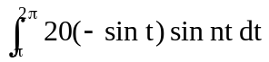

This is an interesting function which will have a value for b₁ but not for any of the other b_{n} terms (they will be zero).

b₁ = [2/(2π)][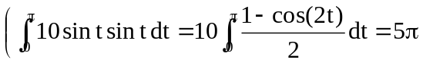
+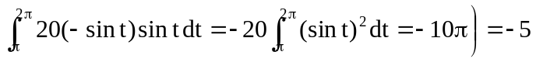

Now we can calculate the rest of the b_{n} for values of n = 2 and greater than 2. We note that,

sin A sin B = 0.5[cos(A–B) – cos(A+B)]

sin t sin nt = 0.5[cos([1–n]t) – cos([1+n]t)]

b_{n} = (5/π){[(sin([1–n]t)/(1–n)) – (sin([1+n]t)/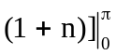

+ [(2sin([1-n]t)/(1-n)) – (2sin([1+n]t)/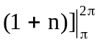}

= 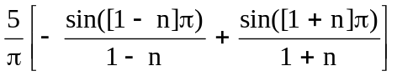 = 0

{Note, that if we substitute 1 for n, the first term is undefined!}

Thus, h(t) = 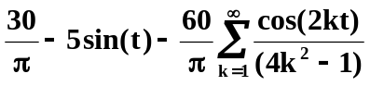

This does make a very good approximation!

